Joshua Haupt

jhaupt@siue.edu

CS 434 Project 3

Joshua Haupt, Charles Helf

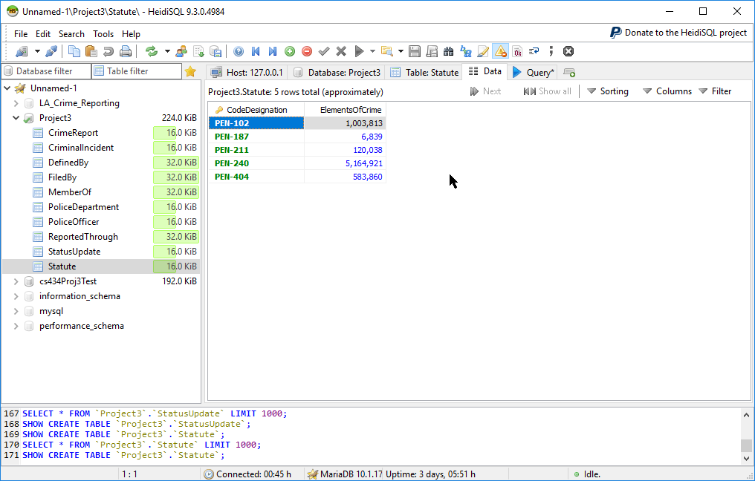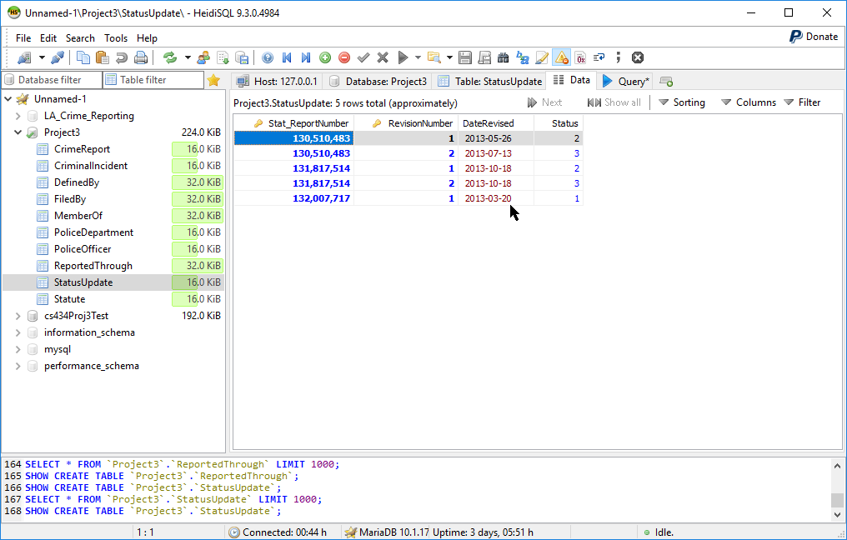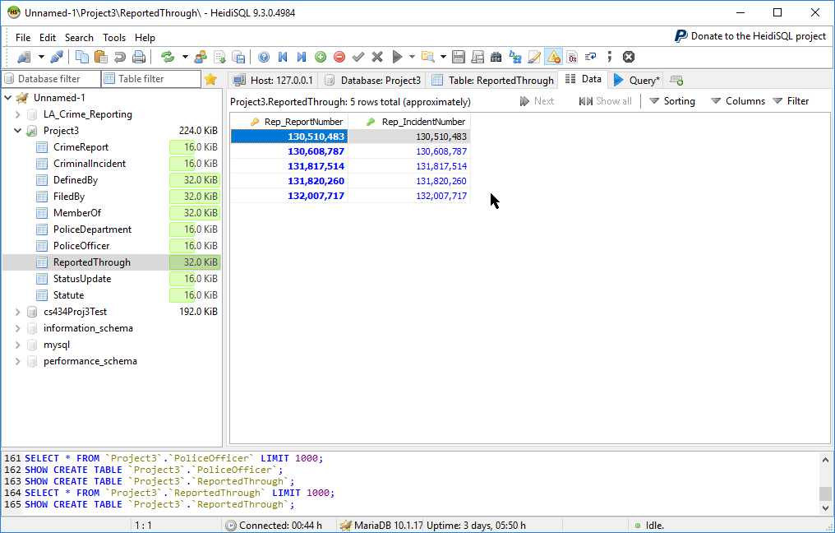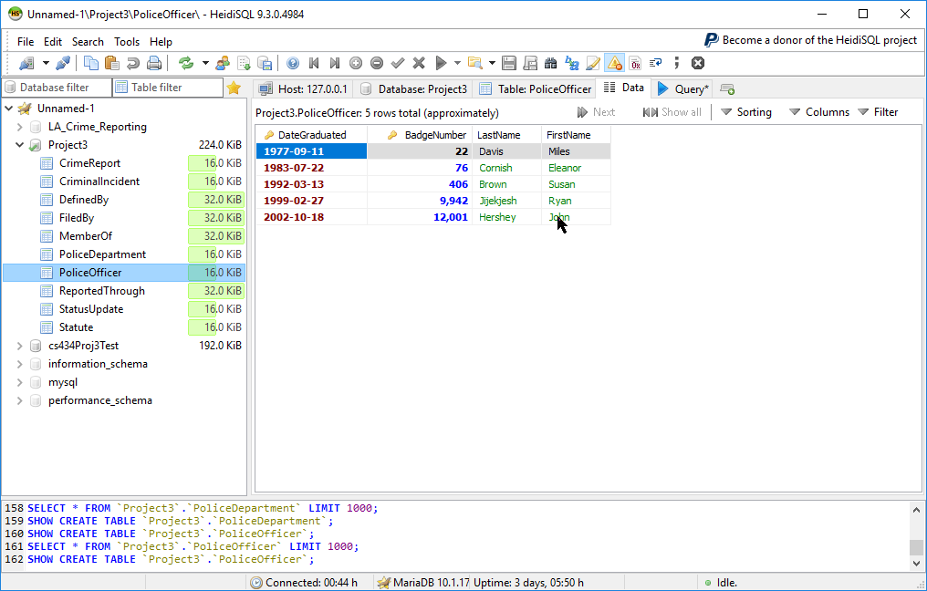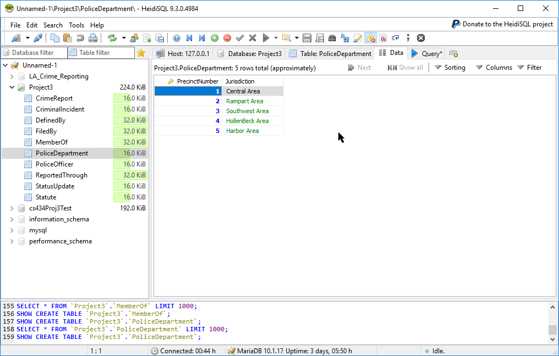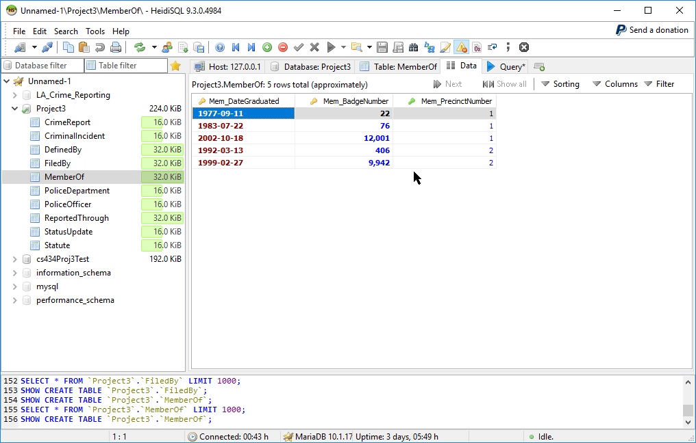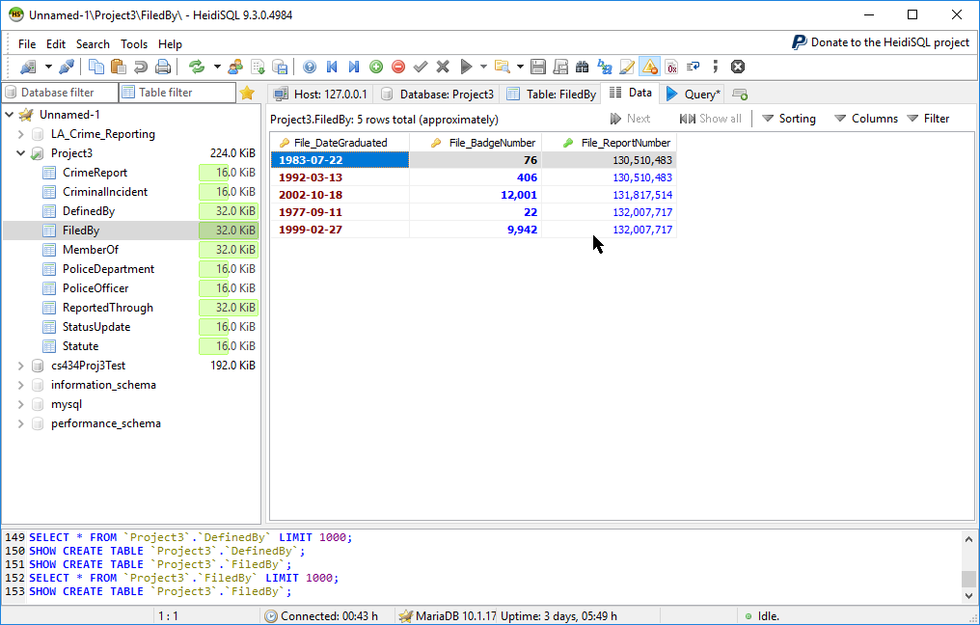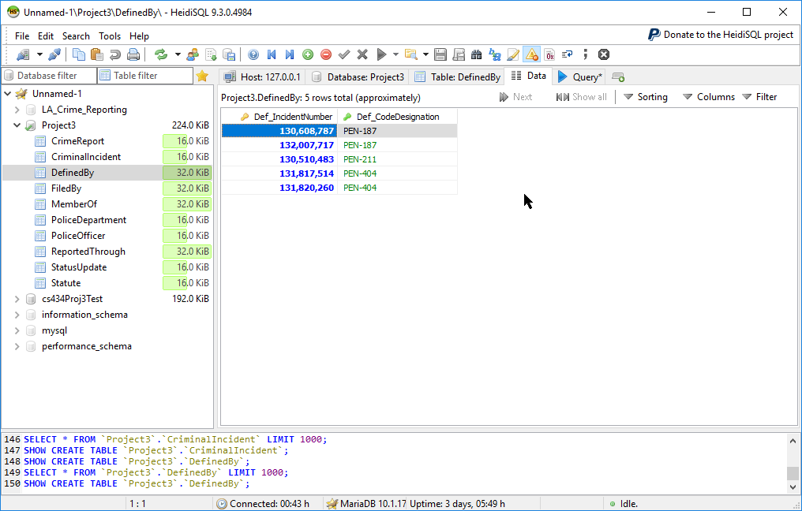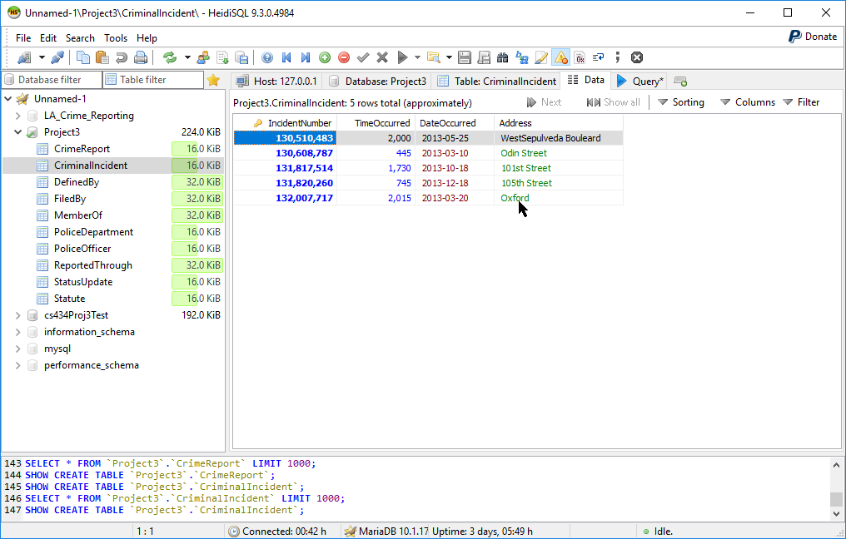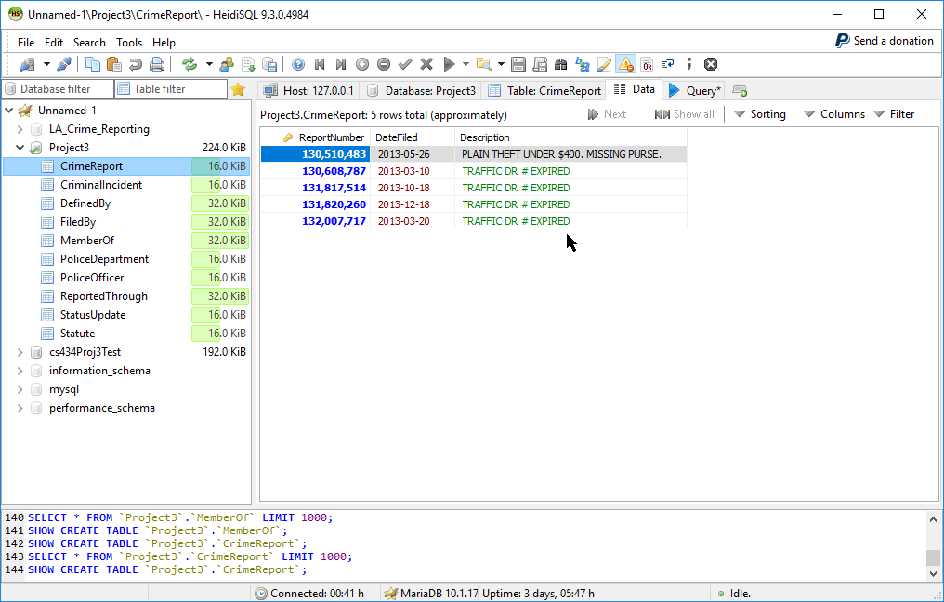

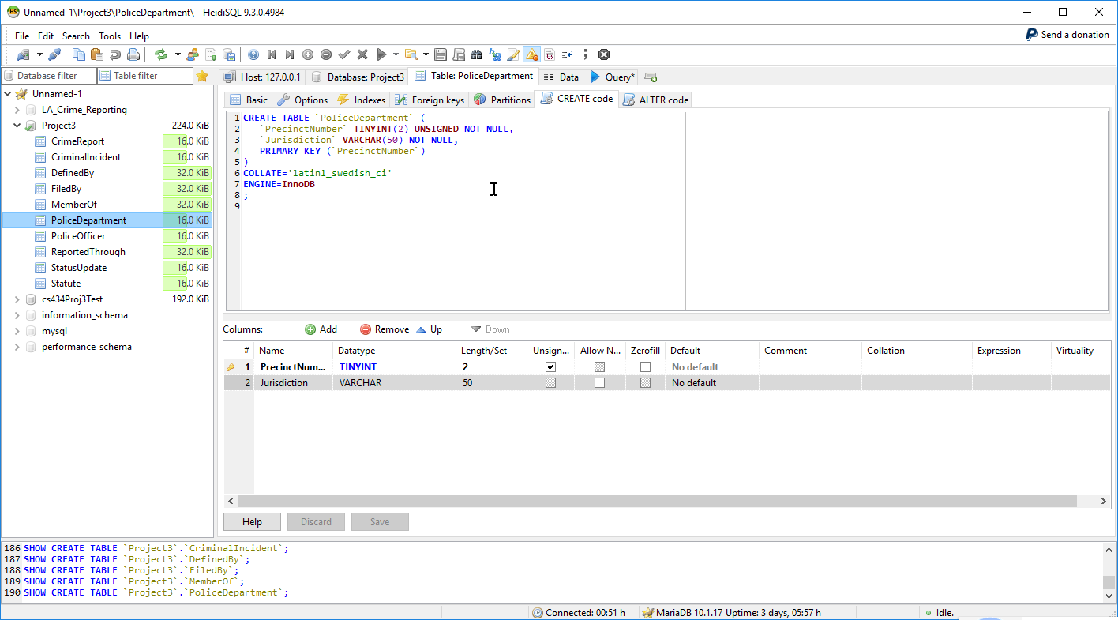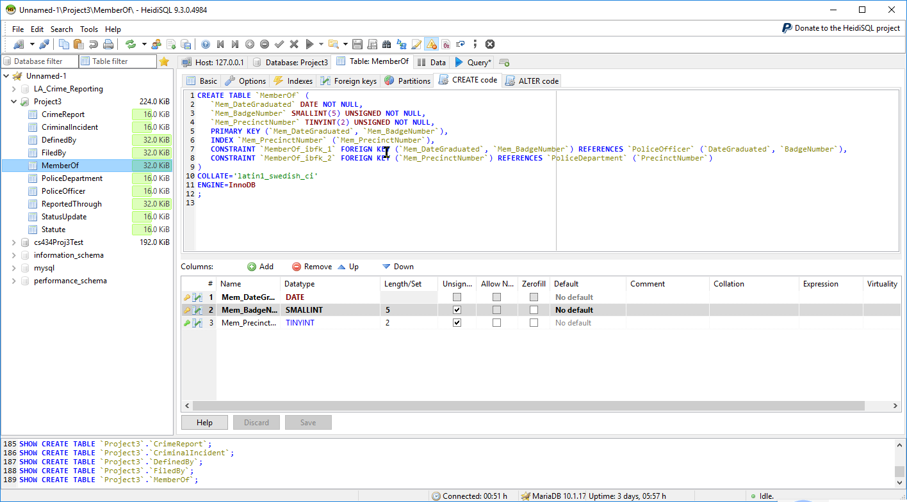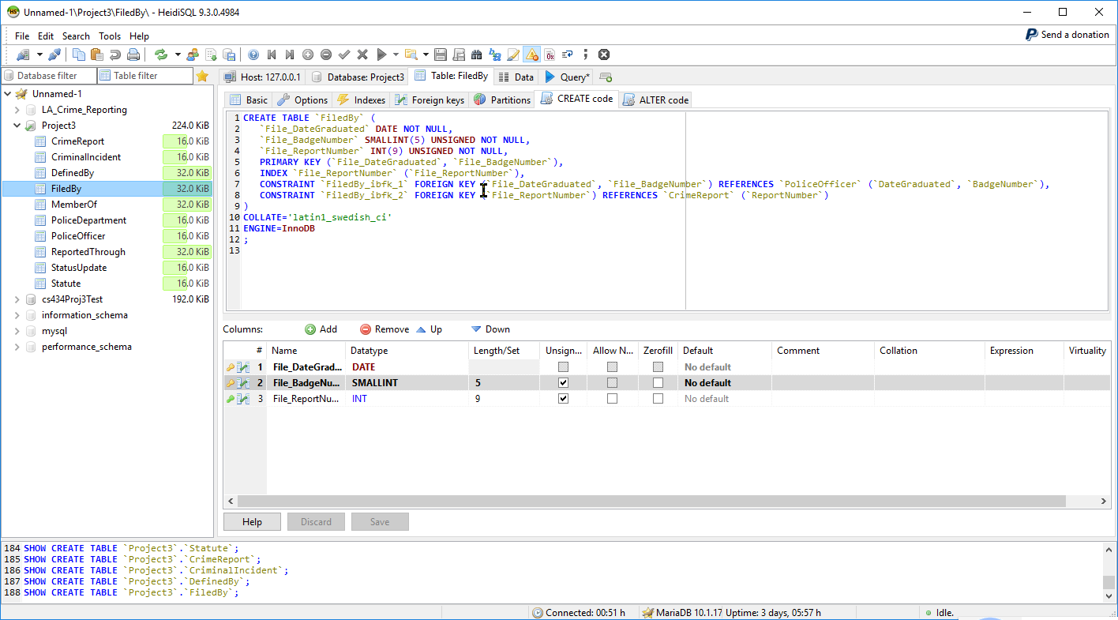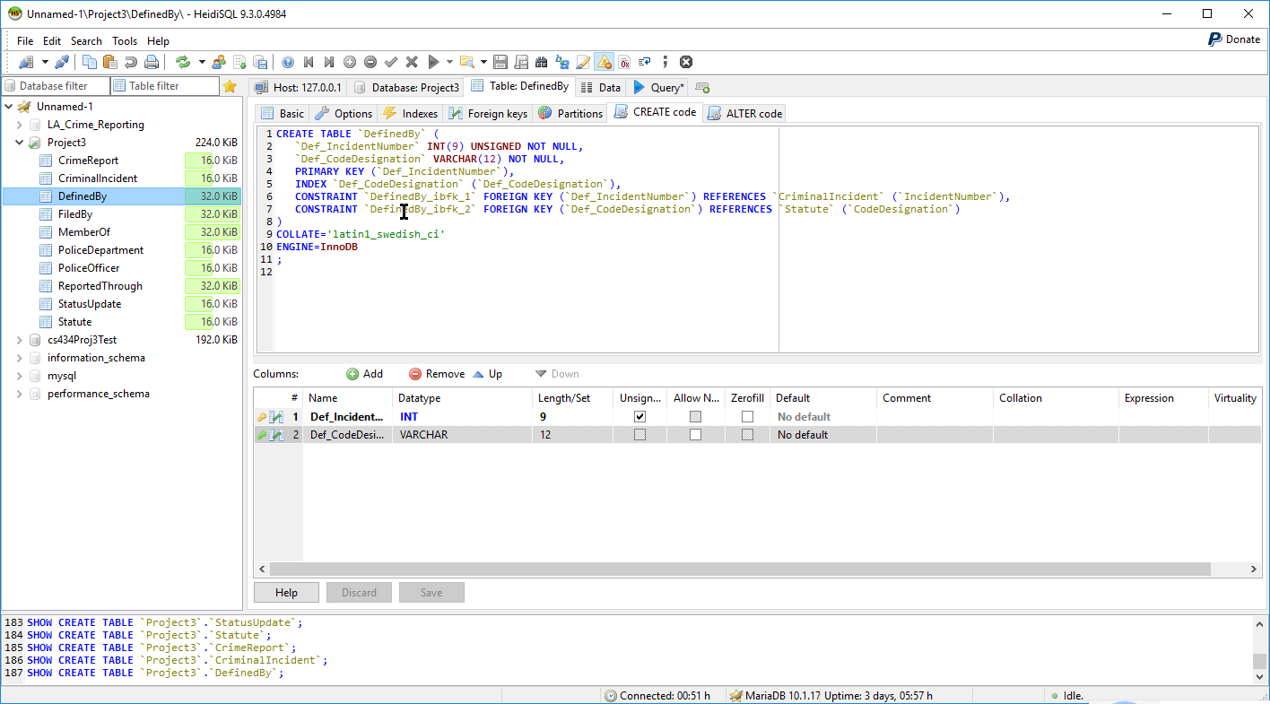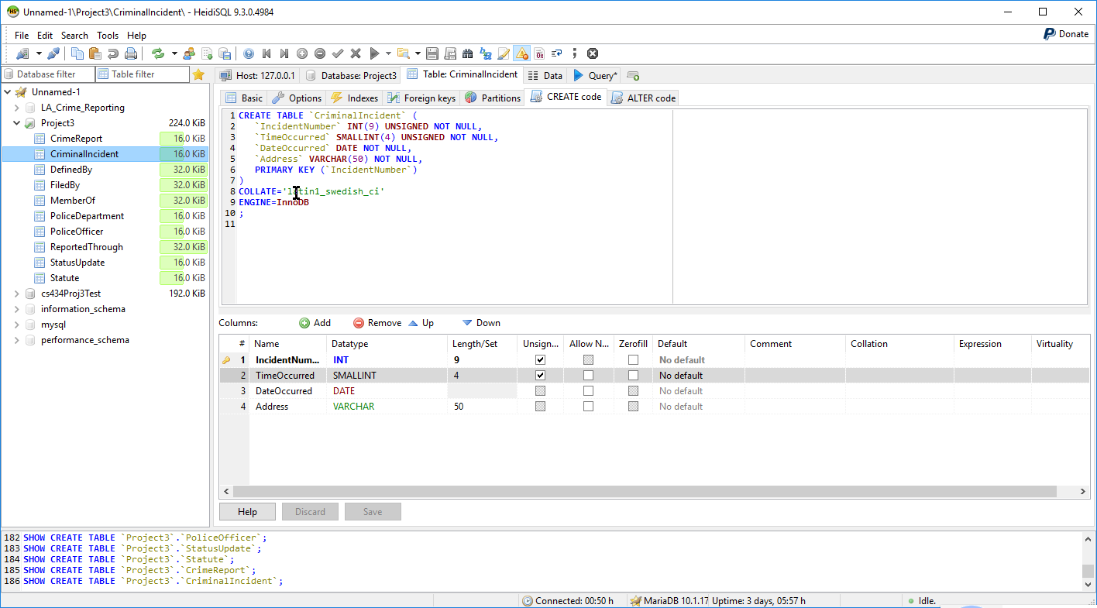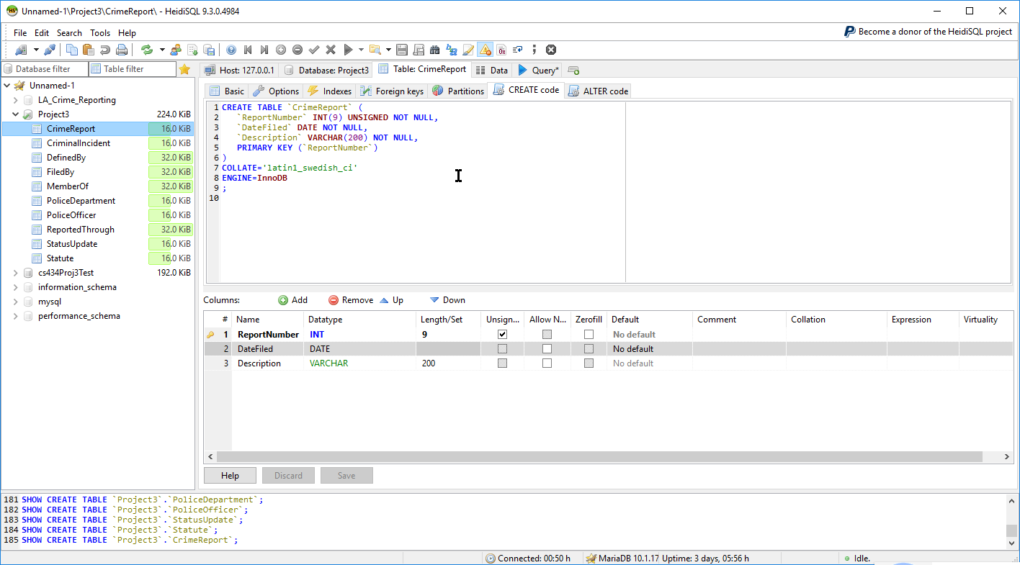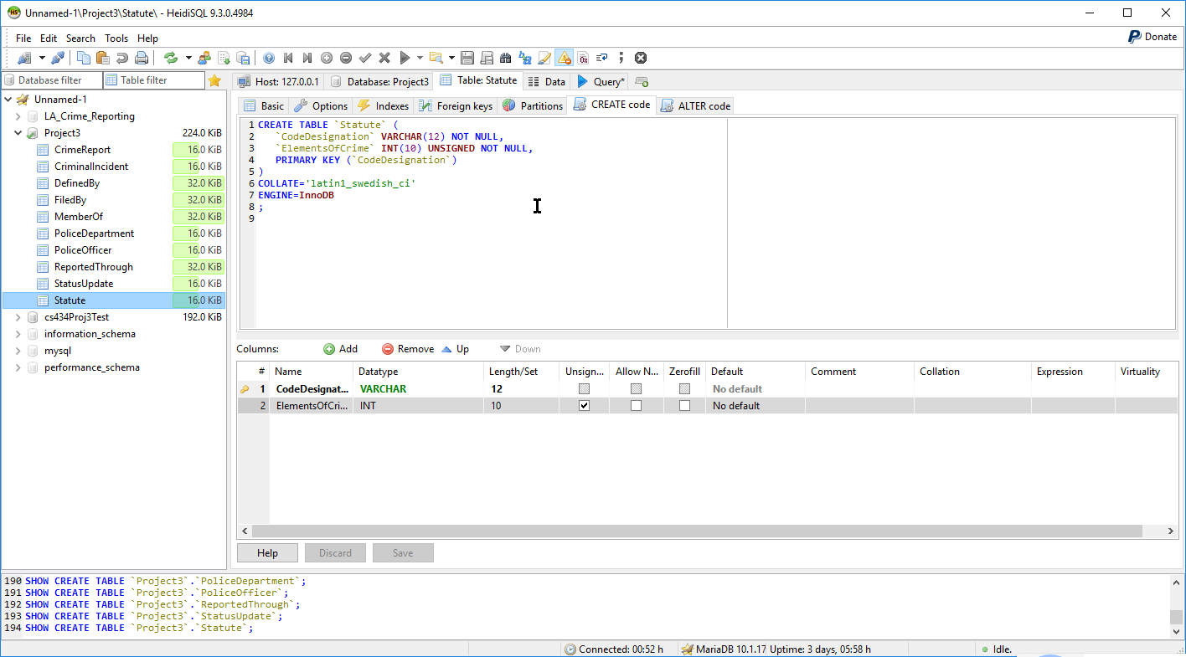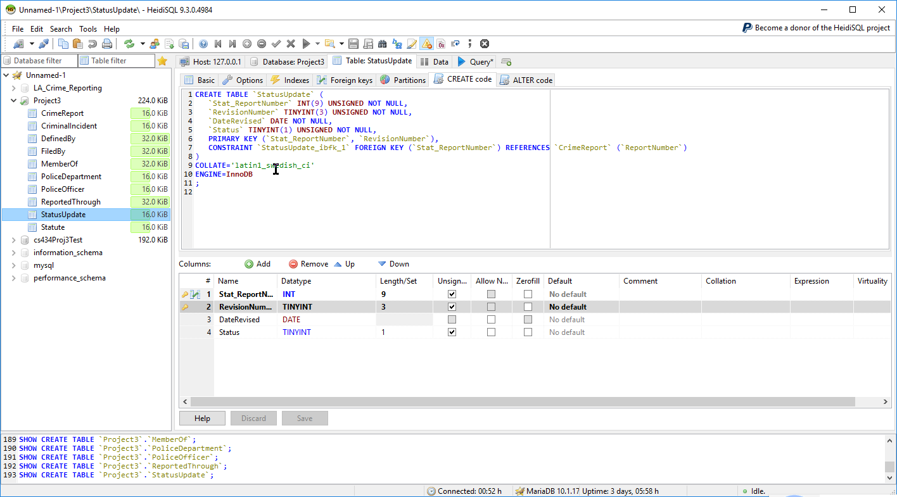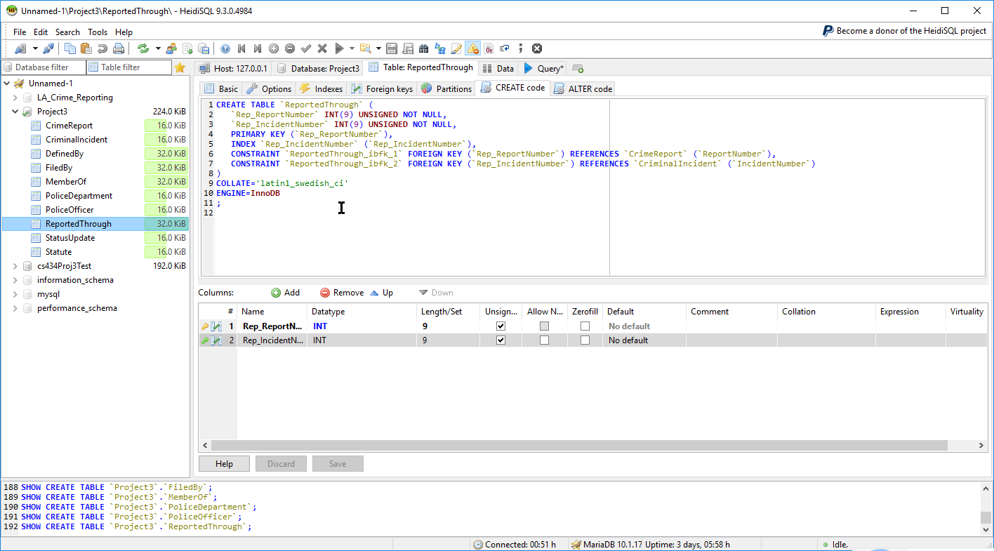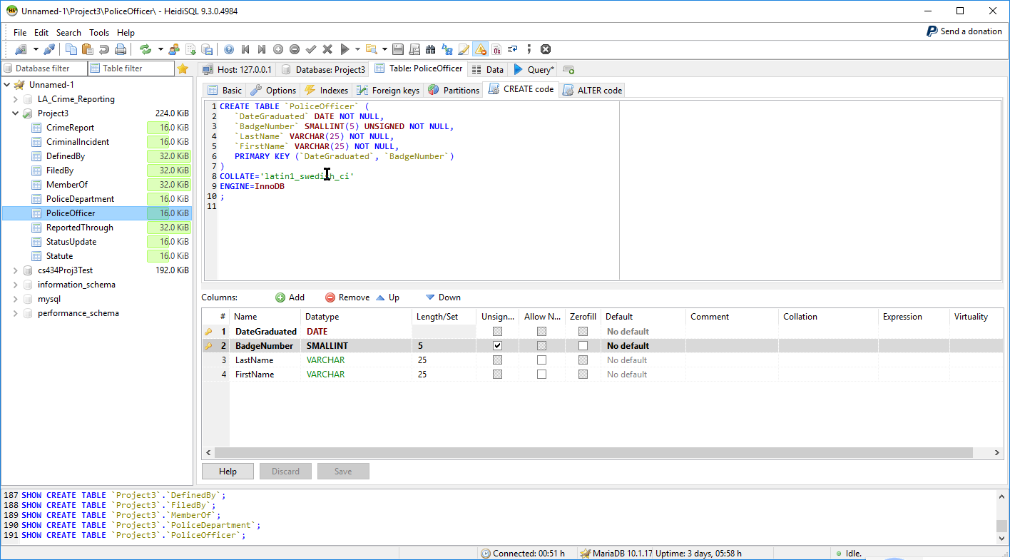

**MySQL Create and Insert Command Statements:**

;

CREATE TABLE IF NOT EXISTS Statute(

CodeDesignation VARCHAR(12) NOT NULL,

ElementsOfCrime INT UNSIGNED NOT NULL,

CONSTRAINT 'pk_code' PRIMARY KEY(CodeDesignation) NOT DEFERRABLE) ENGINE = InnoDB;

CREATE TABLE IF NOT EXISTS Statute( CodeDesignation VARCHAR(12) NOT NULL, ElementsOfCrime INT UNSIGNED NOT NULL, CONSTRAINT 'pk_code' PRIMARY KEY(CodeDesignation) NOT DEFERRABLE) ENGINE = InnoDB;

CREATE TABLE IF NOT EXISTS Statute( CodeDesignation VARCHAR(12) NOT NULL, ElementsOfCrime INT UNSIGNED NOT NULL, CONSTRAINT 'pk_code' PRIMARY KEY(CodeDesignation) NOT DEFERRABLE);

;

CREATE TABLE IF NOT EXISTS Statute(

CodeDesignation VARCHAR(12) NOT NULL,

ElementsOfCrime INT UNSIGNED NOT NULL,

CONSTRAINT pk_code PRIMARY KEY(CodeDesignation) NOT DEFERRABLE INITIALLY IMMEDIATE

) Engine=InnoDB;

CREATE TABLE IF NOT EXISTS Statute( CodeDesignation VARCHAR(12) NOT NULL, ElementsOfCrime INT UNSIGNED NOT NULL, CONSTRAINT pk_code PRIMARY KEY(CodeDesignation) NOT DEFERRABLE INITIALLY IMMEDIATE ) Engine=InnoDB;

CREATE TABLE IF NOT EXISTS Statute( CodeDesignation VARCHAR(12) NOT NULL, ElementsOfCrime INT UNSIGNED NOT NULL, CONSTRAINT pk_code PRIMARY KEY(CodeDesignation) NOT DEFERRABLE INITIALLY IMMEDIATE) Engine=InnoDB;

CREATE TABLE IF NOT EXISTS Statute( CodeDesignation VARCHAR(12) NOT NULL, ElementsOfCrime INT UNSIGNED NOT NULL, CONSTRAINT pk_code PRIMARY KEY CodeDesignation NOT DEFERRABLE INITIALLY IMMEDIATE) Engine=InnoDB;

CREATE TABLE IF NOT EXISTS Statute (Code Designation VARCHAR(12) NOT NULL, ElementsOfCrime INT UNSIGNED NOT NULL, CONSTRAINT pk_code PRIMARY KEY (Code Designation) NOT DEFERRABLE INITIALLY IMMEDIATE) Engine = InnoDB;

CREATE TABLE IF NOT EXISTS Statute (Code Designation VARCHAR(12) NOT NULL, ElementsOfCrime INT UNSIGNED NOT NULL, PRIMARY KEY (CodeDesignation) NOT DEFERRABLE) ENGINE = InnoDB;

CREATE TABLE IF NOT EXISTS Statute (Code Designation VARCHAR(12) NOT NULL, ElementsOfCrime INT UNSIGNED NOT NULL, PRIMARY KEY (CodeDesignation)) ENGINE = InnoDB;

;

CREATE TABLE IF NOT EXISTS Statute (CodeDesignation VARCHAR(12) NOT NULL) ENGINE=InnoDB;

drop table Statute;

CREATE TABLE IF NOT EXISTS Statute (CodeDesignation VARCHAR(12) NOT NULL, ElementsOfCrime INT UNSIGNED NOT NULL, PRIMARY KEY (CodeDesignation)) Engine=InnoDB;

drop Statute;

CREATE TABLE IF NOT EXISTS Statute (CodeDesignation VARCHAR(12) NOT NULL, ElementsOfCrime INT UNSIGNED NOT NULL, PRIMARY KEY (CodeDesignation) NOT DEFERRABLE) Engine=InnoDB;

;

drop Statute;

drop table Statute;

CREATE TABLE IF NOT EXISTS Statute (CodeDeignation VARCHAR(12) NOT NULL, ElementsOfCrime INT UNSIGNED NOT NULL, PRIMARY KEY CodeDesignation NOT DEFERRABLE) ENGINE = InnoDB;

CREATE TABLE IF NOT EXISTS Statute (CodeDeignation VARCHAR(12) NOT NULL, ElementsOfCrime INT UNSIGNED NOT NULL, PRIMARY KEY CodeDesignation NOT DEFERRABLE);

CREATE TABLE IF NOT EXISTS Statute (CodeDeignation VARCHAR(12) NOT NULL, ElementsOfCrime INT UNSIGNED NOT NULL, PRIMARY KEY CodeDesignation DEFERRABLE);

CREATE TABLE Statute (CodeDesignation VARCHAR(12) NOT NULL, ElementsOfCrime INT UNSIGNED NOT NULL, PRIMARY KEY CodeDesignation) ENGINE = InnoDB;

CREATE TABLE Statute (CodeDesignation VARCHAR(12) NOT NULL, ElementsOfCrime INT UNSIGNED NOT NULL, PRIMARY KEY (CodeDesignation)) ENGINE = InnoDB;

drop table Statute;

CREATE TABLE Statute (CodeDesignation VARCHAR(12) NOT NULL, ElementsOfCrime INT UNSIGNED NOT NULL, PRIMARY KEY (CodeDesignation) NOT DEFERRABLE) ENGINE = InnoDB;

drop table Statute;

CREATE TABLE Statute (CodeDesignation VARCHAR(12) NOT NULL, ElementsOfCrime INT UNSIGNED NOT NULL, PRIMARY KEY (CodeDesignation) DEFERRABLE) ENGINE = InnoDB;

CREATE TABLE Statute (CodeDesignation VARCHAR(12) NOT NULL, ElementsOfCrime INT UNSIGNED NOT NULL, CONSTRAINT 'pk_codedes' PRIMARY KEY (CodeDesignation) DEFERRABLE) ENGINE = InnoDB;

CREATE TABLE Statute (CodeDesignation VARCHAR(12) NOT NULL, ElementsOfCrime INT UNSIGNED NOT NULL, CONSTRAINT 'pk_codedes' PRIMARY KEY (CodeDesignation)) ENGINE = InnoDB;

CREATE TABLE Statute (CodeDesignation VARCHAR(12) NOT NULL, ElementsOfCrime INT UNSIGNED NOT NULL, PRIMARY KEY (CodeDesignation)) ENGINE = InnoDB;

;

;

;

drop table Statute;

CREATE TABLE Statute (CodeDesignation VARCHAR(12) NOT NULL, ElementsOfCrime INT UNSIGNED NOT NULL, CONSTRAINT `pk_code` PRIMARY KEY (CodeDesignation) NOT DEFERRABLE) ENGINE = InnoDB;

CREATE TABLE Statute (CodeDesignation VARCHAR(12) NOT NULL, ElementsOfCrime INT UNSIGNED NOT NULL, PRIMARY KEY (CodeDesignation)); ENGINE = InnoDB;

;

drop table Statute;

CREATE TABLE Statute(CodeDesignation VARCHAR(12) NOT NULL, ElementsOfCrime INT UNSIGNED NOT NULL, PRIMARY KEY (CodeDesignation)) ENGINE = InnoDB;

CREATE TABLE CriminalIncident(IncidentNumber INT(9) UNSIGNED NOT NULL, TimeOccurred SMALLINT(4) UNSIGNED NOT NULL, DateOccurred DATE NOT NULL, Address VARCHAR(50) NOT NULL, PRIMARY KEY(IncidentNumber) Engine = InnoDB;

CREATE TABLE CriminalIncident ( IncidentNumber INT(9) UNSIGNED NOT NULL, TimeOccurred SMALLINT(4) UNSIGNED NOT NULL, DateOccurred DATE NOT NULL, Address VARCHAR(50) NOT NULL, PRIMARY KEY(IncidentNumber)) Engine = InnoDB;

CREATE TABLE DefinedBy(Def_IncidentNumber INT(9) UNSIGNED NOT NULL, Def_CodeDesignation VARCHAR(12) NOT NULL, PRIMARY KEY (Def_IncidentNumber), FOREIGN KEY (Def_IncidentNumber) REFERENCES CriminalIncident(IncidentNumber), FOREIGN KEY (Def_CodeDesignation) REFERENCES Statute(CodeDesignation) ENGINE = InnoDB;

CREATE TABLE DefinedBy(Def_IncidentNumber INT(9) UNSIGNED NOT NULL, Def_CodeDesignation VARCHAR(12) NOT NULL, PRIMARY KEY (Def_IncidentNumber), FOREIGN KEY (Def_IncidentNumber) REFERENCES CriminalIncident(IncidentNumber), FOREIGN KEY (Def_CodeDesignation) REFERENCES Statute(CodeDesignation)) ENGINE = InnoDB;

CREATE TABLE CrimeReport( ReportNumber INT(9) UNSIGNED NOT NULL, DateFiled DATE NOT NULL, Description VARCHAR(200) NOT NULL, PRIMARY KEY (ReportNumber)) ENGINE = InnoDB;

CREATE TABLE ReportedThrough( Rep_ReportNumber INT(9) UNSIGNED NOT NULL, Rep_IncidentNumber INT(9) UNSIGNED NOT NULL, PRIMARY KEY (Rep_ReportNumber), FOREIGN KEY (Rep_ReportNumber) REFERENCES CrimeReport(ReportNumber), FOREIGN KEY (Rep_IncidentNumber) REFERENCES CriminalIncident(IncidentNumber)) ENGINE = InnoDB;

CREATE TABLE StatusUpdate( Stat_ReportNumber INT(9) UNSIGNED NOT NULL, RevisionNumber TINYINT UNSIGNED NOT NULL, DateRevised DATE NOT NULL, Status TINYINT(1) UNSIGNED NOT NULL, PRIMARY KEY (Stat_ReportNumber, RevisionNumber), FOREIGN KEY (Stat_ReportNumber) REFERENCES CrimeReport(ReportNumber)) ENGINE = InnoDB;

CREATE TABLE PoliceOfficer (DateGraduated DATE NOT NULL, BadgeNumber SMALLINT(5) UNSIGNED NOT NULL, LastName VARCHAR(25) NOT NULL, FirstName VARCHAR(25) NOT NULL, PRIMARY KEY (DateGraduated, BadgeNumber)) ENGINE = InnoDB;

CREATE TABLE FiledBy (File_DateGraduated DATE NOT NULL, File_BadgeNumber SMALLINT(5) UNSIGNED NOT NULL, File_ReportNumber INT NOT NULL, PRIMARY KEY (File_DateGraduated, File_BadgeNumber), FOREIGN KEY (File_DateGraduated, File_BadgeNumber) REFERENCES PoliceOfficer(DateGraduated, BadgeNumber), FOREIGN KEY (File_ReportNumber) REFERENCES CrimeReport(ReportNumber)) ENGINE = InnoDB;

CREATE TABLE FiledBy (File_DateGraduated DATE NOT NULL, File_BadgeNumber SMALLINT(5) UNSIGNED NOT NULL, File_ReportNumber INT NOT NULL, PRIMARY KEY (File_DateGraduated, File_BadgeNumber), FOREIGN KEY (File_DateGraduated, File_BadgeNumber) REFERENCES PoliceOfficer(DateGraduated, BadgeNumber), FOREIGN KEY (File_ReportNumber) REFERENCES CrimeReport (ReportNumber)) ENGINE = InnoDB;

;

describe FiledBy

;

show create table FiledBy;

show create table DescribedIn;

;

show create table definedby;

show create table DefinedBy;

;

CREATE TABLE FiledBy ( File_DateGraduated DATE NOT NULL, File_BadgeNumber SMALLINT(5) UNSIGNED NOT NULL, File_ReportNumber INT(9) NOT NULL, PRIMARY KEY (File_DateGraduated, File_BadgeNumber), FOREIGN KEY (File_DateGraduated, File_BadgeNumber) REFERENCES PoliceOfficer (DateGraduated, BadgeNumber), FOREIGN KEY (File_ReportNumber) REFERENCES CrimeReport (ReportNumber)) ENGINE = InnoDB;

CREATE TABLE FiledBy ( File_DateGraduated DATE NOT NULL, File_BadgeNumber SMALLINT(5) UNSIGNED NOT NULL, File_ReportNumber INT(9) UNSIGNED NOT NULL, PRIMARY KEY (File_DateGraduated, File_BadgeNumber), FOREIGN KEY (File_DateGraduated, File_BadgeNumber) REFERENCES PoliceOfficer (DateGraduated, BadgeNumber), FOREIGN KEY (File_ReportNumber) REFERENCES CrimeReport (ReportNumber)) ENGINE = InnoDB;

;

CREATE TABLE PoliceDepartment ( PrecinctNumber TINYINT(2) UNSIGNED NOT NULL, Jurisdiction VARCHAR(50) NOT NULL, PRIMARY KEY (PrecinctNumber)) ENGINE = InnoDB;

CREATE TABLE MemberOf ( Mem_DateGraduated DATE NOT NULL, Mem_BadgeNumber SMALLINT(5) UNSIGNED NOT NULL, Mem_PrecinctNumber TINYINT (2) UNSIGNED NOT NULL, PRIMARY KEY (Mem_DateGraduated, Mem_BadgeNumber), FOREIGN KEY (Mem_DateGraduated, Mem_BadgeNumber) REFERENCES PoliceOfficer (DateGraduated, BadgeNumber), FOREIGN KEY (Mem_PrecicntNumber) REFERENCES PoliceDepartment (PrecinctNumber)) ENGINE = InnoDB;

CREATE TABLE MemberOf ( Mem_DateGraduated DATE NOT NULL, Mem_BadgeNumber SMALLINT(5) UNSIGNED NOT NULL, Mem_PrecinctNumber TINYINT (2) UNSIGNED NOT NULL, PRIMARY KEY (Mem_DateGraduated, Mem_BadgeNumber), FOREIGN KEY (Mem_DateGraduated, Mem_BadgeNumber) REFERENCES PoliceOfficer (DateGraduated, BadgeNumber), FOREIGN KEY (Mem_PrecinctNumber) REFERENCES PoliceDepartment (PrecinctNumber)) ENGINE = InnoDB;

;

;

INSERT INTO Statute (CodeDesignation, ElementsOfCrime) VALUES ('PEN-102', 1003813), ('PEN-211', 120038), ('PEN-240', 5164921), ('PEN-187', 6839), ('PEN-404', 583860);

INSERT INTO PoliceOfficer (DateGraduated, BadgeNumber, LastName, FIrstName) VALUES ('2002-10-18', 12001, 'Hershey', 'John'), ('1999-02-27', 9942, 'Jijekjesh', 'Ryan'), ('1983-07-22', 76, 'Cornish', 'Eleanor'), ('1992-03-13', 406, 'Brown', 'Susan'), ('1977-09-11', 22, 'Davis', 'Miles');

INSERT INTO PoliceDepartment (PrecinctNumber, Jurisdiction) VALUES (1, 'Central Area'), (2, 'Rampart Area'), (3, 'Southwest Area'), (4, 'HollenBeck Area'), (5, 'Harbor Area');

INSERT INTO DefinedBy (Def_IncidentNumber, Def_CodeDesignation) VALUES (132007717, 'PEN-187'), (130608787, 'PEN-187'), (131820260, 'PEN-404'), (131817514, 'PEN-404'), (130510483, 'PEN-211');

show table PoliceOfficer;

show PoliceOfficer;

select * from PoliceOfficer;

select * from MemberOf;

select * from PoliceDepartment;

INSERT INTO DefinedBy (Def_IncidentNumber, Def_CodeDesignation) VALUES (132007717, 'PEN-187'), (130608787, 'PEN-187'), (131820260, 'PEN-404'), (131817514, 'PEN-404'), (130510483, 'PEN-211');

select * from DefinedBy;

;

select * from CriminalIncident;

select * from PoliceOfficer;

INSERT INTO CriminalIncident (IncidentNumber, TimeOccurred, DateOccurred, Address) VALUES (132007717, 2015, '2013-03-20', 'Oxford'), (130608787, 445, '2013-03-10', 'Odin Street'), (131820260, 745, '2013-12-18', '105th Street'), (131817514, 1730, '2013-10-18', '101st Street'), (130510483, 2000, '2013-05-25', 'WestSepulveda Bouleard');

INSERT INTO DefinedBy (Def_IncidentNumber, Def_CodeDesignation) VALUES (132007717, 'PEN-187'), (130608787, 'PEN-187'), (131820260, 'PEN-404'), (131817514, 'PEN-404'), (130510483, 'PEN-211');

select * from ReportedThrough;

INSERT INTO ReportedThrough (Rep_ReportNumber, Rep_IncidentNumber) VALUES (132007717, 132007717), (130608787, 130608787), (131820260, 131820260), (131817514, 131817514), (130510483, 130510483);

;

;

INSERT INTO CrimeReport (ReportNumber, DateFiled, Description) VALUES (132007717, '2013-03-20', 'TRAFFIC DR # EXPIRED'), (130608787, '2013-03-10', 'TRAFFIC DR # EXPIRED'), (131820260, '2013-12-18', 'TRAFFIC DR # EXPIRED'), (131817514, '2013-10-18', 'TRAFFIC DR # EXPIRED'), (130510483, '2013-05-26', 'PLAIN THEFT UNDER $400. MISSING PURSE.');

INSERT INTO ReportedThrough (Rep_ReportNumber, Rep_IncidentNumber) VALUES (132007717, 132007717), (130608787, 130608787), (131820260, 131820260), (131817514, 131817514), (130510483, 130510483);

INSERT INTO StatusUpdate (Stat_ReportNumber, RevisionNumber, DateRevised, Status) VALUES (132007717, 1, '2013-03-20', 1), (130510483, 1, '2013-05-26', 2), (130510483, 2, '2013-07-13', 3), (131817514, 1, '2013-10-18', 2), (131817514, '2013-10-18', 3);

INSERT INTO StatusUpdate (Stat_ReportNumber, RevisionNumber, DateRevised, Status) VALUES (132007717, 1, '2013-03-20', 1), (130510483, 1, '2013-05-26', 2), (130510483, 2, '2013-07-13', 3), (131817514, 1, '2013-10-18', 2), (131817514, 2, '2013-10-18', 3);

select * from PoliceOfficer;

INSERT INTO FiledBy (File_DateGraduated, File_BadgeNumber, File_ReportNumber) VALUES ('1977-09-11', 22' 132007717), ('1999-02-27', 9942, 132007717), ('1992-03-13', 406, 130510483), ('1983-07-22', 76, 130510483), ('1977-09-11', 22, 131817514);

;

'

;

INSERT INTO FiledBy (File_DateGraduated, File_BadgeNumber, File_ReportNumber) VALUES ('1977-09-11', 22' 132007717), ('1999-02-27', 9942, 132007717), ('1992-03-13', 406, 130510483), ('1983-07-22', 76, 130510483), ('1977-09-11', 22, 131817514);\012;\012\012';

INSERT INTO FiledBy (File_DateGraduated, File_BadgeNumber, File_ReportNumber) VALUES ('1977-09-11', 22, 132007717), ('1999-02-27', 9942, 132007717), ('1992-03-13', 406, 130510483), ('1983-07-22', 76, 130510483), ('1977-09-11', 22, 131817514);

select * from FiledBy;

INSERT INTO FiledBy (File_DateGraduated, File_BadgeNumber, File_ReportNumber) VALUES ('1977-09-11', 22, 132007717), ('1999-02-27', 9942, 132007717), ('1992-03-13', 406, 130510483), ('1983-07-22', 76, 130510483), ('2002-10-18', 12001, 131817514);

INSERT INTO MemberOf (Mem_DateGraduated, Mem_BadgeNumber, Mem_PrecinctNumber) VALUES ('1977-09-11', 22, 1), ('1999-02-27', 9942, 2), ('2002-10-18', 12001, 1), ('1983-07-22', 76, 1), ('1992-03-13', 406, 2);

Create Command Statements:

**CREATE** **TABLE** `CrimeReport` (

`ReportNumber` **INT**(9) **UNSIGNED** **NOT** **NULL**,

`DateFiled` **DATE** **NOT** **NULL**,

`Description` **VARCHAR**(200) **NOT** **NULL**,

**PRIMARY** **KEY** (`ReportNumber`)

)

**COLLATE**='latin1_swedish_ci'

**ENGINE**=**InnoDB**

;

**CREATE** **TABLE** `CriminalIncident` (

`IncidentNumber` **INT**(9) **UNSIGNED** **NOT** **NULL**,

`TimeOccurred` **SMALLINT**(4) **UNSIGNED** **NOT** **NULL**,

`DateOccurred` **DATE** **NOT** **NULL**,

`Address` **VARCHAR**(50) **NOT** **NULL**,

**PRIMARY** **KEY** (`IncidentNumber`)

)

**COLLATE**='latin1_swedish_ci'

**ENGINE**=**InnoDB**

;

**CREATE** **TABLE** `DefinedBy` (

`Def_IncidentNumber` **INT**(9) **UNSIGNED** **NOT** **NULL**,

`Def_CodeDesignation` **VARCHAR**(12) **NOT** **NULL**,

**PRIMARY** **KEY** (`Def_IncidentNumber`),

**INDEX** `Def_CodeDesignation` (`Def_CodeDesignation`),

**CONSTRAINT** `DefinedBy_ibfk_1` **FOREIGN** **KEY** (`Def_IncidentNumber`) **REFERENCES** `CriminalIncident` (`IncidentNumber`),

**CONSTRAINT** `DefinedBy_ibfk_2` **FOREIGN** **KEY** (`Def_CodeDesignation`) **REFERENCES** `Statute` (`CodeDesignation`)

)

**COLLATE**='latin1_swedish_ci'

**ENGINE**=**InnoDB**

;

**CREATE** **TABLE** `FiledBy` (

`File_DateGraduated` **DATE** **NOT** **NULL**,

`File_BadgeNumber` **SMALLINT**(5) **UNSIGNED** **NOT** **NULL**,

`File_ReportNumber` **INT**(9) **UNSIGNED** **NOT** **NULL**,

**PRIMARY** **KEY** (`File_DateGraduated`, `File_BadgeNumber`),

**INDEX** `File_ReportNumber` (`File_ReportNumber`),

**CONSTRAINT** `FiledBy_ibfk_1` **FOREIGN** **KEY** (`File_DateGraduated`, `File_BadgeNumber`) **REFERENCES** `PoliceOfficer` (`DateGraduated`, `BadgeNumber`),

**CONSTRAINT** `FiledBy_ibfk_2` **FOREIGN** **KEY** (`File_ReportNumber`) **REFERENCES** `CrimeReport` (`ReportNumber`)

)

**COLLATE**='latin1_swedish_ci'

**ENGINE**=**InnoDB**

;

**CREATE** **TABLE** `MemberOf` (

`Mem_DateGraduated` **DATE** **NOT** **NULL**,

`Mem_BadgeNumber` **SMALLINT**(5) **UNSIGNED** **NOT** **NULL**,

`Mem_PrecinctNumber` **TINYINT**(2) **UNSIGNED** **NOT** **NULL**,

**PRIMARY** **KEY** (`Mem_DateGraduated`, `Mem_BadgeNumber`),

**INDEX** `Mem_PrecinctNumber` (`Mem_PrecinctNumber`),

**CONSTRAINT** `MemberOf_ibfk_1` **FOREIGN** **KEY** (`Mem_DateGraduated`, `Mem_BadgeNumber`) **REFERENCES** `PoliceOfficer` (`DateGraduated`, `BadgeNumber`),

**CONSTRAINT** `MemberOf_ibfk_2` **FOREIGN** **KEY** (`Mem_PrecinctNumber`) **REFERENCES** `PoliceDepartment` (`PrecinctNumber`)

)

**COLLATE**='latin1_swedish_ci'

**ENGINE**=**InnoDB**

;

**CREATE** **TABLE** `PoliceDepartment` (

`PrecinctNumber` **TINYINT**(2) **UNSIGNED** **NOT** **NULL**,

`Jurisdiction` **VARCHAR**(50) **NOT** **NULL**,

**PRIMARY** **KEY** (`PrecinctNumber`)

)

**COLLATE**='latin1_swedish_ci'

**ENGINE**=**InnoDB**

;

**CREATE** **TABLE** `PoliceOfficer` (

`DateGraduated` **DATE** **NOT** **NULL**,

`BadgeNumber` **SMALLINT**(5) **UNSIGNED** **NOT** **NULL**,

`LastName` **VARCHAR**(25) **NOT** **NULL**,

`FirstName` **VARCHAR**(25) **NOT** **NULL**,

**PRIMARY** **KEY** (`DateGraduated`, `BadgeNumber`)

)

**COLLATE**='latin1_swedish_ci'

**ENGINE**=**InnoDB**

;

**CREATE** **TABLE** `ReportedThrough` (

`Rep_ReportNumber` **INT**(9) **UNSIGNED** **NOT** **NULL**,

`Rep_IncidentNumber` **INT**(9) **UNSIGNED** **NOT** **NULL**,

**PRIMARY** **KEY** (`Rep_ReportNumber`),

**INDEX** `Rep_IncidentNumber` (`Rep_IncidentNumber`),

**CONSTRAINT** `ReportedThrough_ibfk_1` **FOREIGN** **KEY** (`Rep_ReportNumber`) **REFERENCES** `CrimeReport` (`ReportNumber`),

**CONSTRAINT** `ReportedThrough_ibfk_2` **FOREIGN** **KEY** (`Rep_IncidentNumber`) **REFERENCES** `CriminalIncident` (`IncidentNumber`)

)

**COLLATE**='latin1_swedish_ci'

**ENGINE**=**InnoDB**

;

**CREATE** **TABLE** `StatusUpdate` (

`Stat_ReportNumber` **INT**(9) **UNSIGNED** **NOT** **NULL**,

`RevisionNumber` **TINYINT**(3) **UNSIGNED** **NOT** **NULL**,

`DateRevised` **DATE** **NOT** **NULL**,

`Status` **TINYINT**(1) **UNSIGNED** **NOT** **NULL**,

**PRIMARY** **KEY** (`Stat_ReportNumber`, `RevisionNumber`),

**CONSTRAINT** `StatusUpdate_ibfk_1` **FOREIGN** **KEY** (`Stat_ReportNumber`) **REFERENCES** `CrimeReport` (`ReportNumber`)

)

**COLLATE**='latin1_swedish_ci'

**ENGINE**=**InnoDB**

;

**CREATE** **TABLE** `Statute` (

`CodeDesignation` **VARCHAR**(12) **NOT** **NULL**,

`ElementsOfCrime` **INT**(10) **UNSIGNED** **NOT** **NULL**,

**PRIMARY** **KEY** (`CodeDesignation`)

)

**COLLATE**='latin1_swedish_ci'

**ENGINE**=**InnoDB**

;